

Course: Database Management Systems Lab
Project: Employee Management System
Teacher: Bushra Aziz
By
Faraz Hussain (FA22-BESE-0003), Taha Naveed (FA22-BESE-0007) And Kamran Ali (FA22-BESE-0029)

INTRODUCTION
This report details the implementation of an Employee Management System (EMS) using SQL Server for database management and Python for application logic. The EMS is designed to efficiently handle various aspects of employee information, including departments, positions, salaries, and user authentication.
An Employee Management System (EMS) is a comprehensive software solution designed to manage and streamline various aspects of employee administration within an organization. This project, developed using SQL and Python, leverages the robust data management capabilities of SQL and the versatility of Python to create a user-friendly, efficient, and scalable system.
The EMS project aims to facilitate the automation of key functions such as employee record keeping, payroll management, and record keeping for departments and positions within an organization. The SQL database serves as the backbone of the system, storing all data in a structured format, while Python scripts handle the application logic, data processing, and user’s interactions with the system and database, and interface elements.
By integrating SQL and Python, the system ensures data integrity, security, and quick access to information, making it an invaluable tool for organizations looking to enhance productivity and accuracy in managing their workforce.

ER DIAGRAM

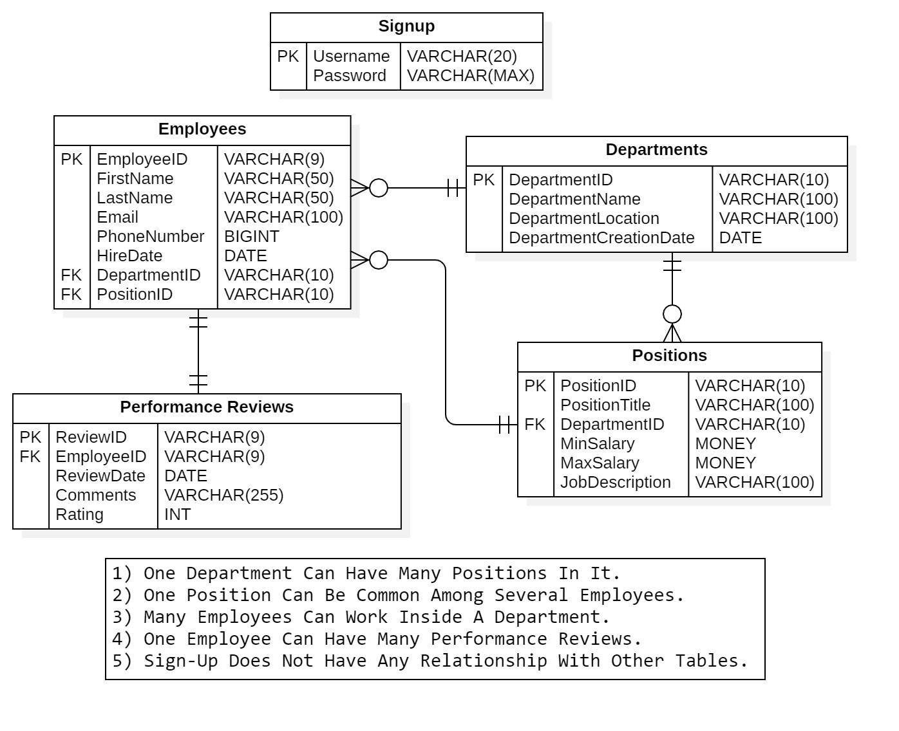

SQL SERVER IMPLEMENTATION
- Creating Database: The EMS begins with the creation of a dedicated database named ‘EmployeeManagementDB’. This database is the foundation where all data related to employees, departments, positions, salaries, and user credentials are stored.
- Creating Tables: Several tables are created within the ‘EmployeeManagementDB’ database to organize and store data:
- Departments Table: This table holds information about different departments within the organization. Each department has a unique identifier and a name.
- Positions Table: This table stores details about various job positions. Each position is associated with a specific department and has a unique identifier and a name.
- Employees Table: This table contains employee data, including personal details, position, department, and hire date. Each employee has a unique identifier.
- Performance Reviews Table: This table records information regarding the performance of employees, including the comments and performance rating. Each review is linked to an employee by foreign key constraint.
- Signup Table: This table manages user authentication details, storing usernames, password hashes, and salts for secure login processes.
- Creating Database View: A database view named ‘EmployeeManagementView’ is created to provide a comprehensive view of employee information by joining the ‘Employees’, ‘Departments’, ‘Positions’ and ‘Salaries’ tables. This view simplifies querying and reporting by presenting a consolidated dataset.
- Inserting Data Into The Tables: Data insertion involves populating the tables with initial data. For example, departments are added to the ‘Departments’ table, positions are added to the ‘Positions’ table, employee records are added to the ‘Employees’ table and performance review records for employees are added to the ‘Performance Reviews’ table. This step is crucial for setting up the EMS with relevant organizational data.
- Displaying Data From The Tables: Data retrieval operations are performed to display information stored in the tables. For instance, querying the ‘Employees’ table can provide a list that contains details of all employees along with their department, and position IDs. This feature is essential for generating reports and accessing employee data as needed.
- Error And Exception Handling Mechanisms: Robust error and exception handling mechanisms are implemented to ensure the EMS can gracefully handle any unexpected issues during database operations. This includes using try-catch blocks to manage SQL errors and providing meaningful error messages and error codes to users.
- Batch Separation: Batch separation involves organizing SQL statements into batches using the ‘GO’ statement. This practice helps manage large scripts by dividing them into smaller, executable segments, improving readability and maintainability. The involvement of this feature will also ensure that if any query fails during execution, all other queries before and after that query do execute successfully.

SQL QUERY SCREENSHOTS
QUERY 01 & 02:
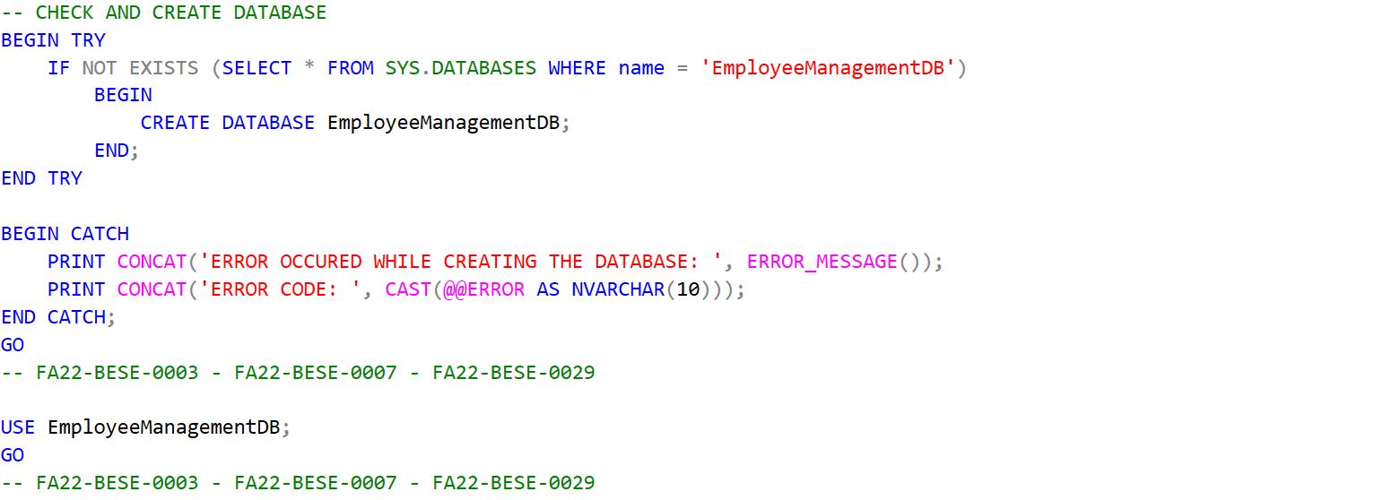

QUERY 03:
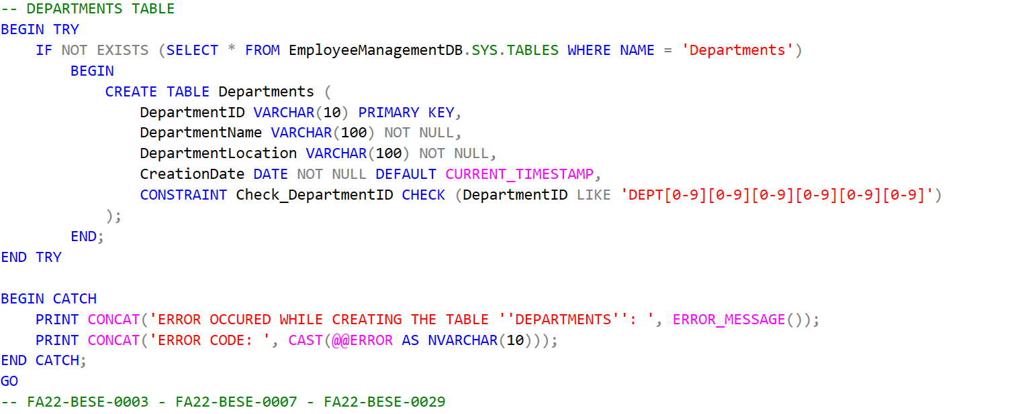

QUERY 04:
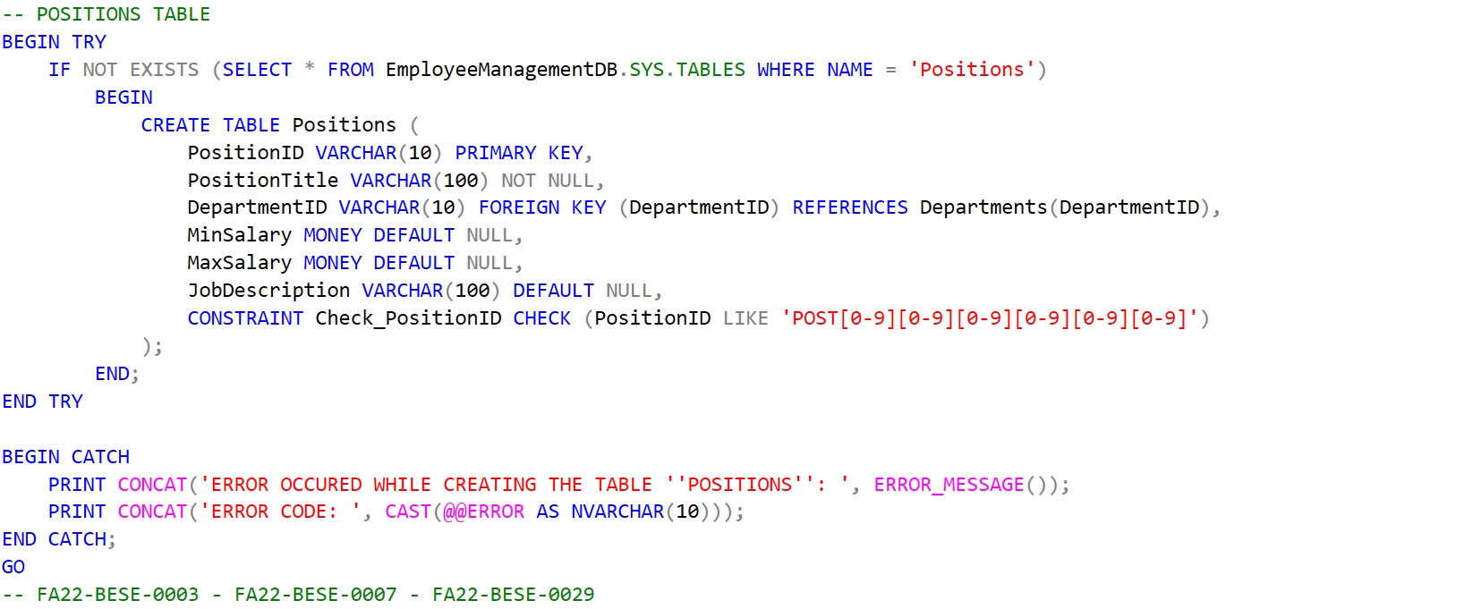

QUERY 05:
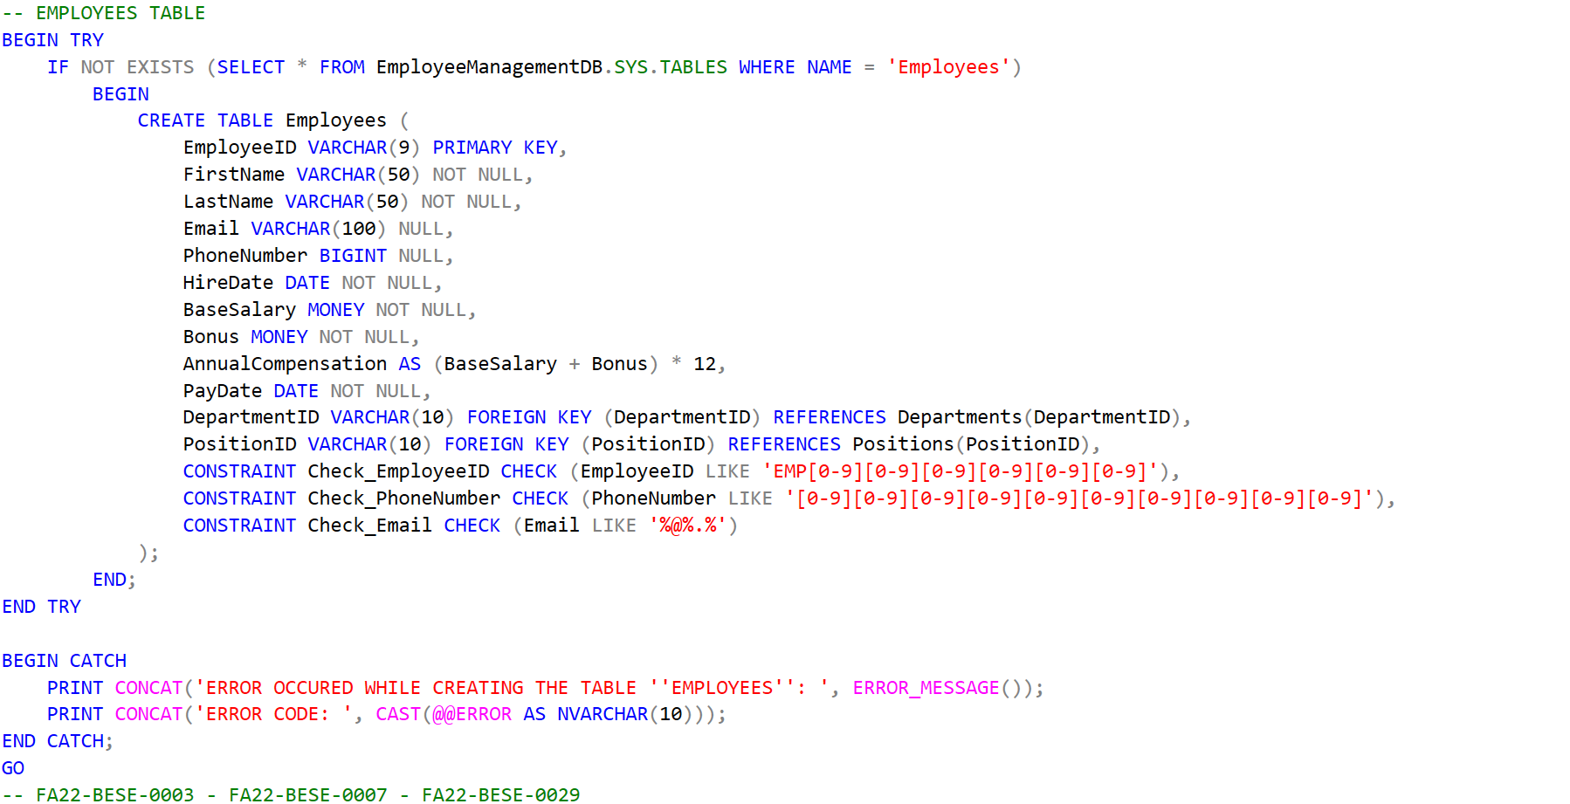

QUERY 06:
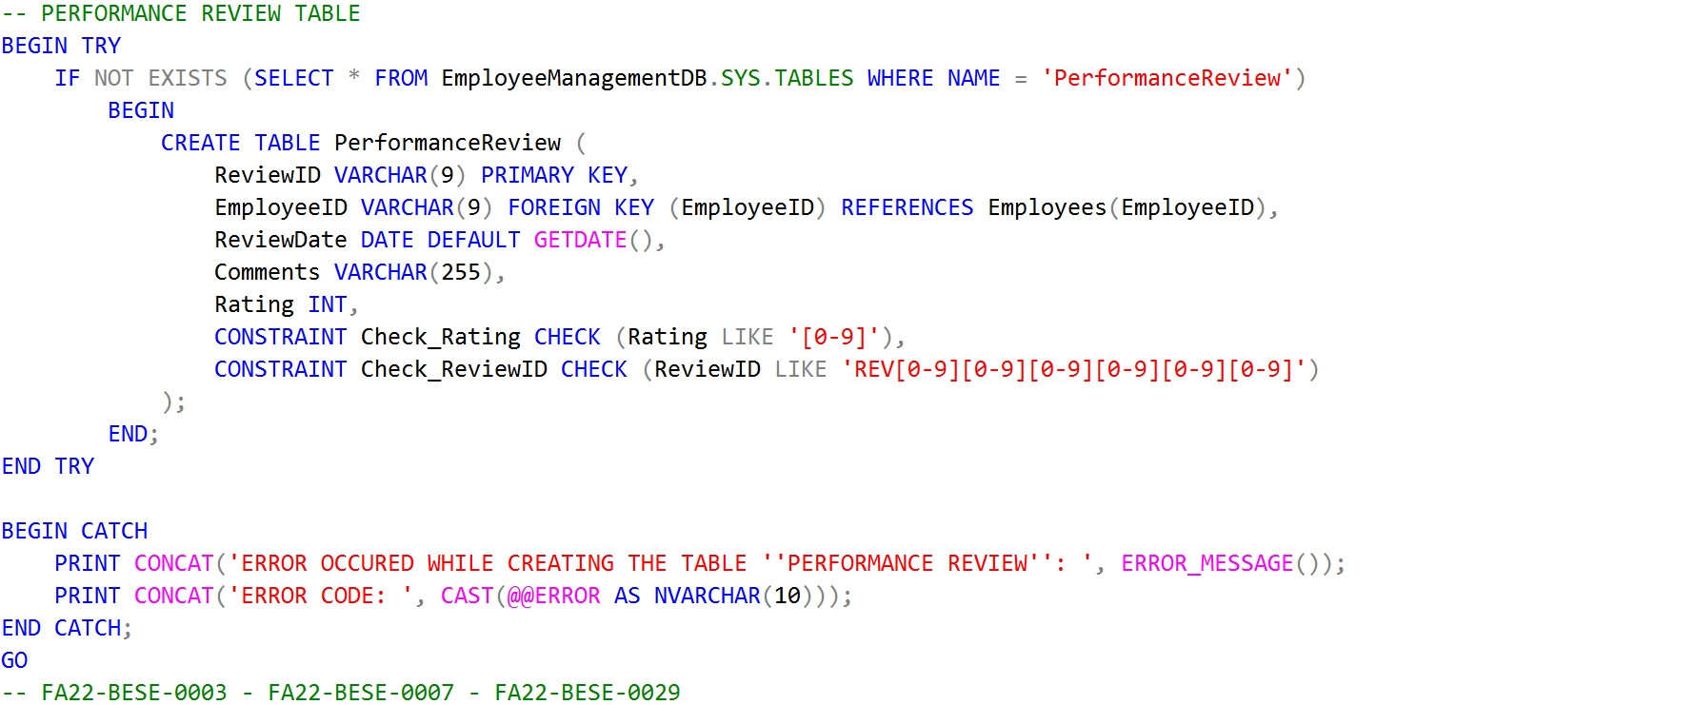

QUERY 07:
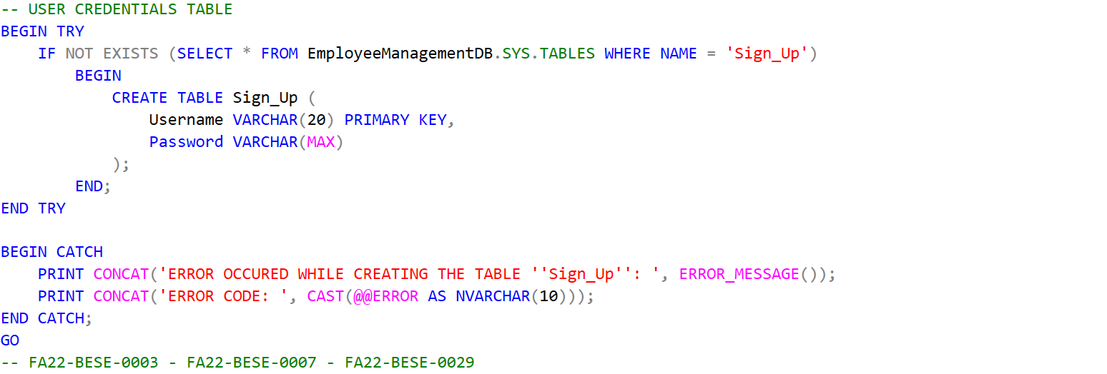

QUERY 08:
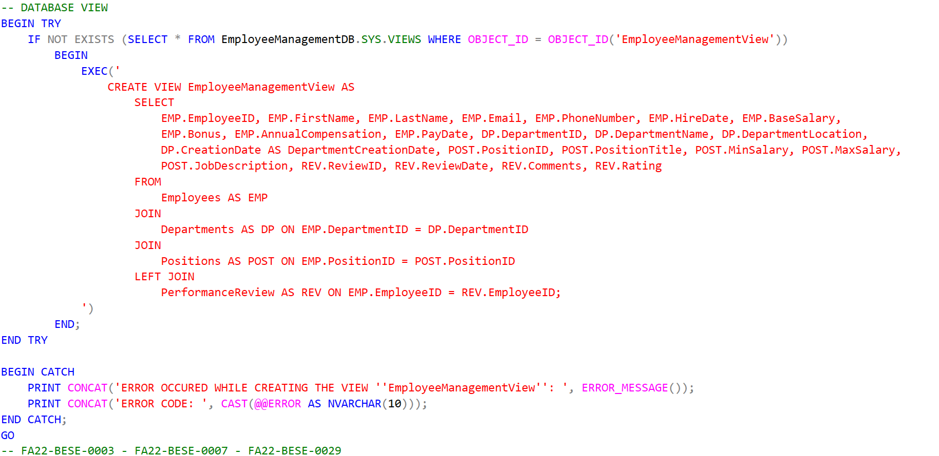

QUERY 09:
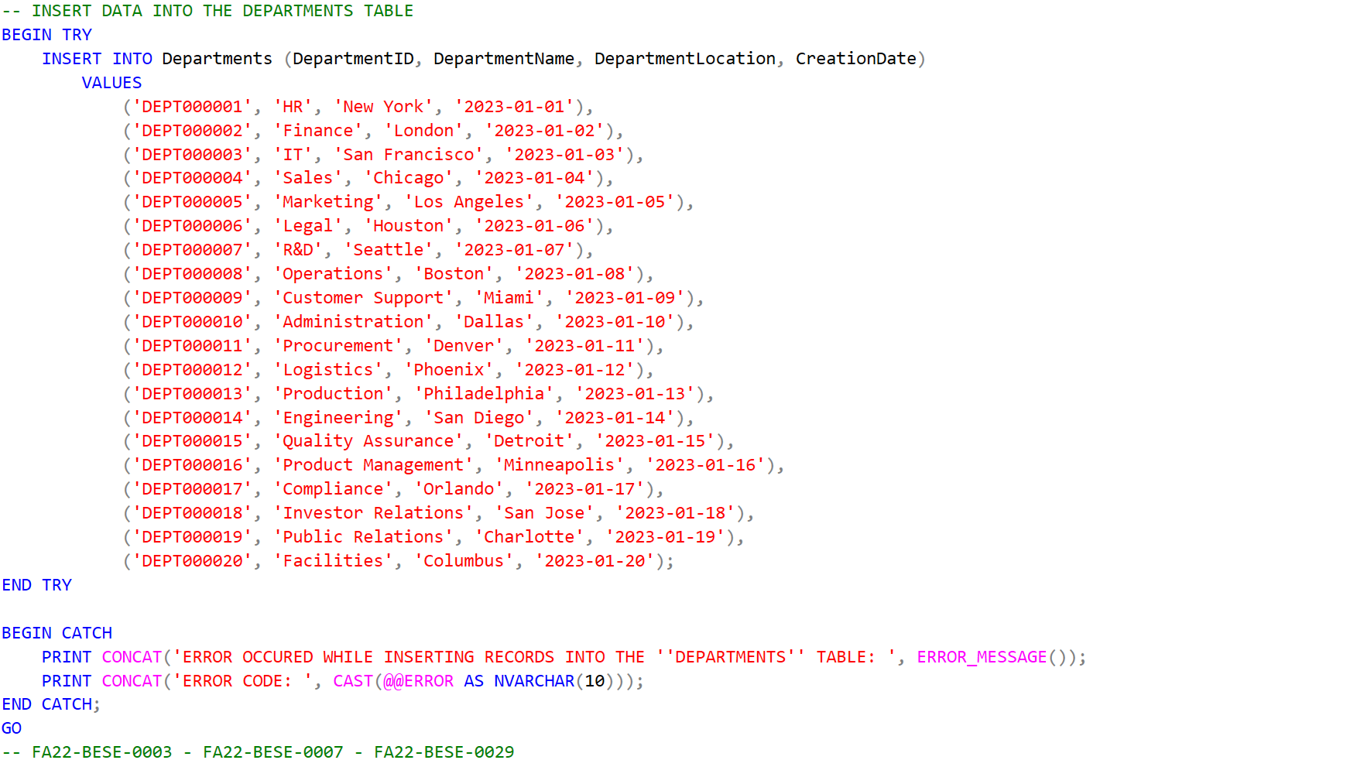

QUERY 10:
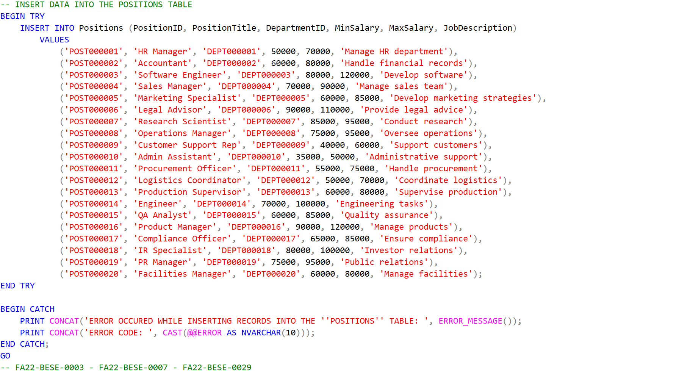

QUERY 11:
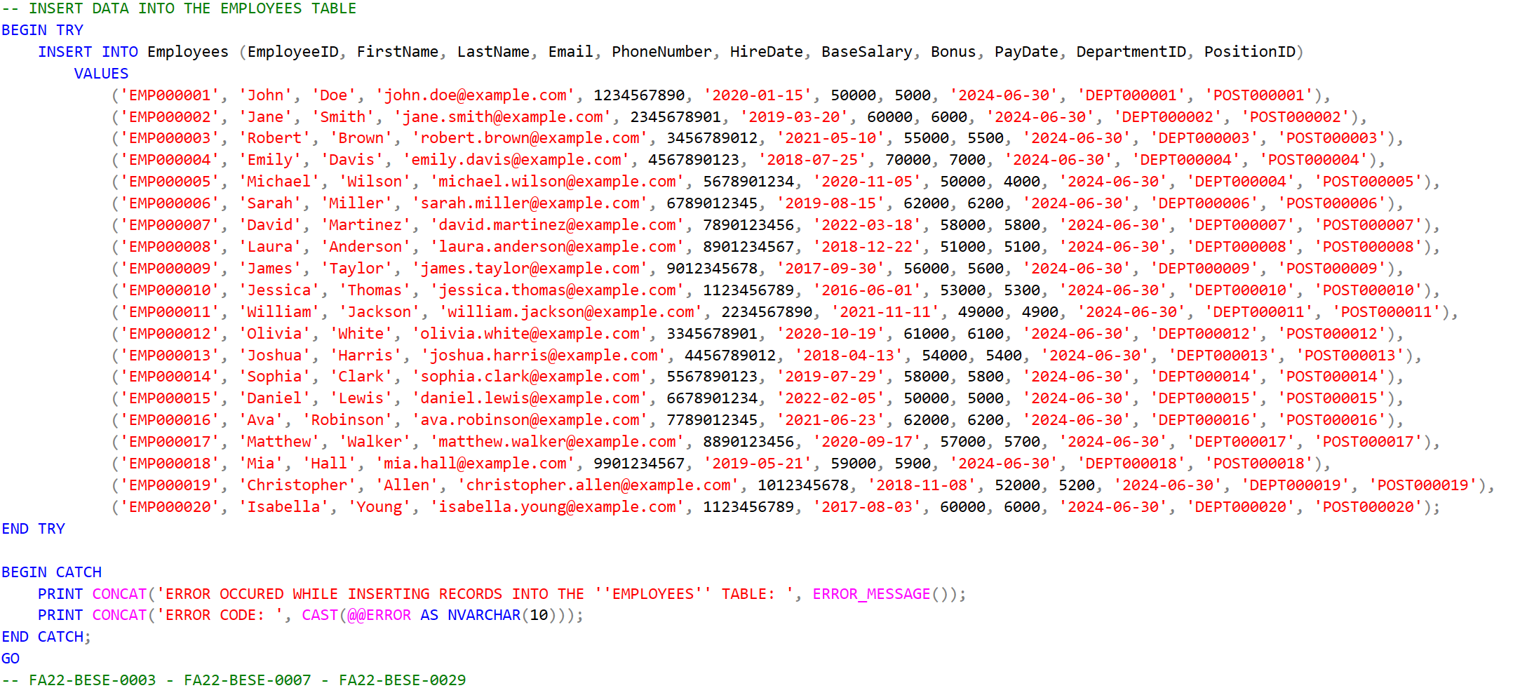

QUERY 12:
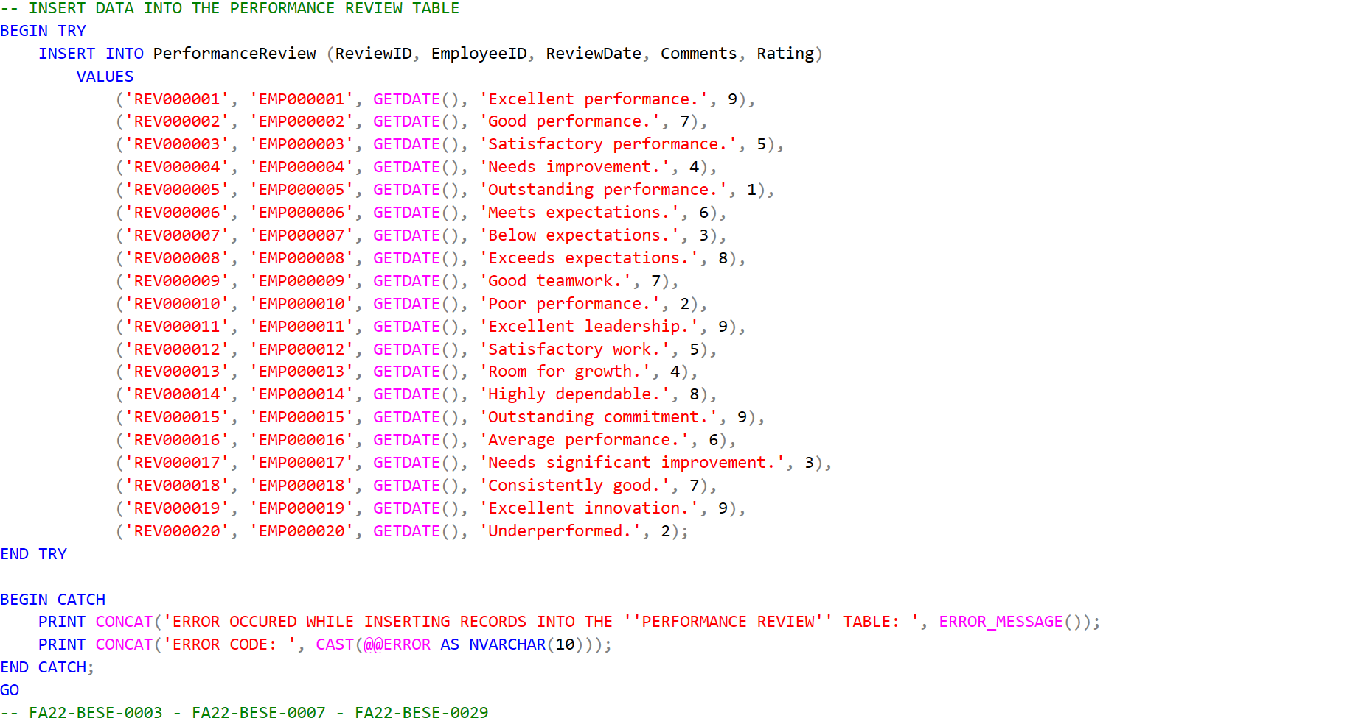

QUERY 13 & 14:
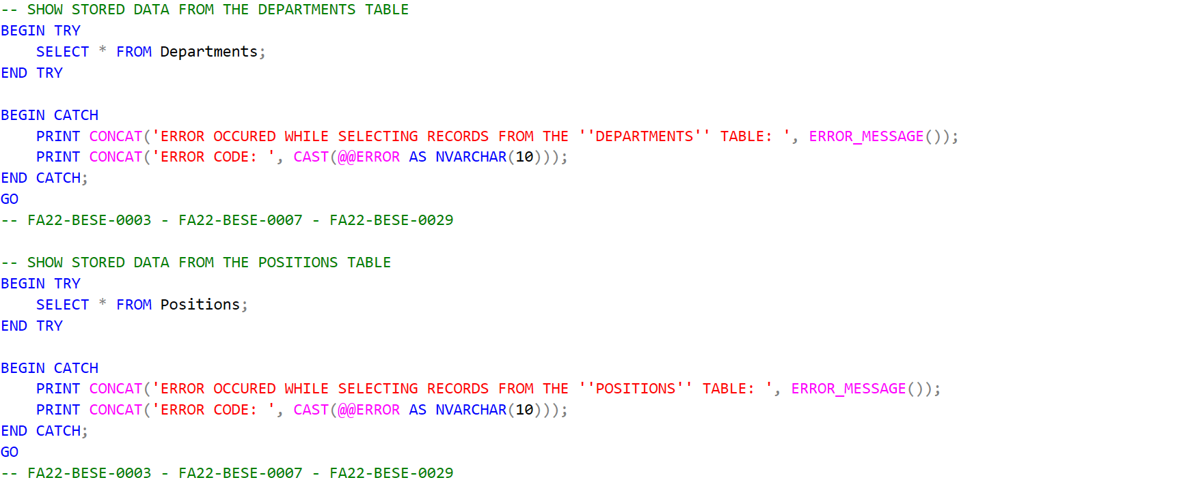

QUERY 15 & 16:
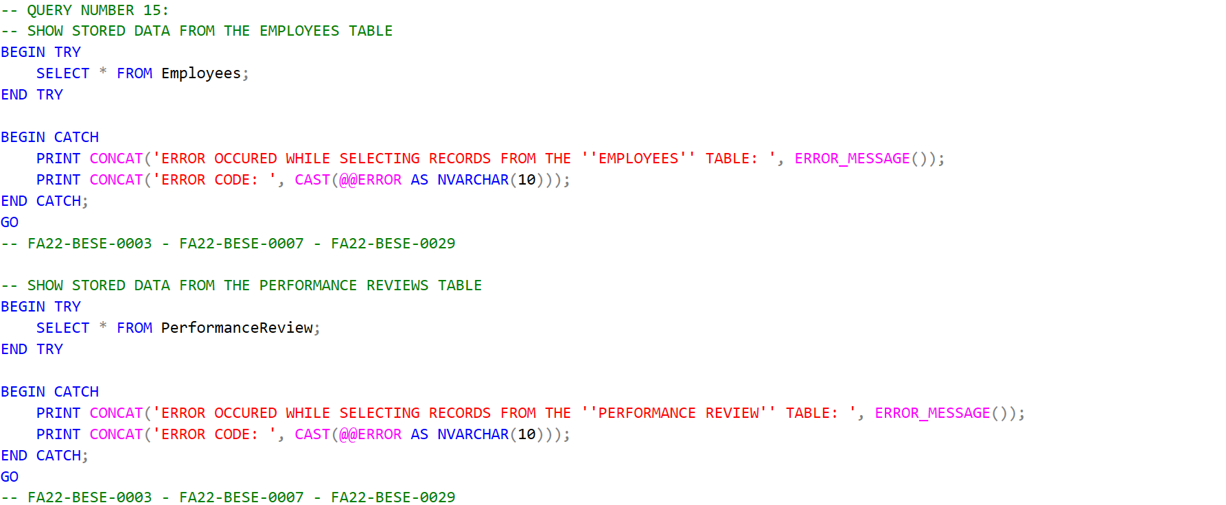

QUERY 17 & 18:
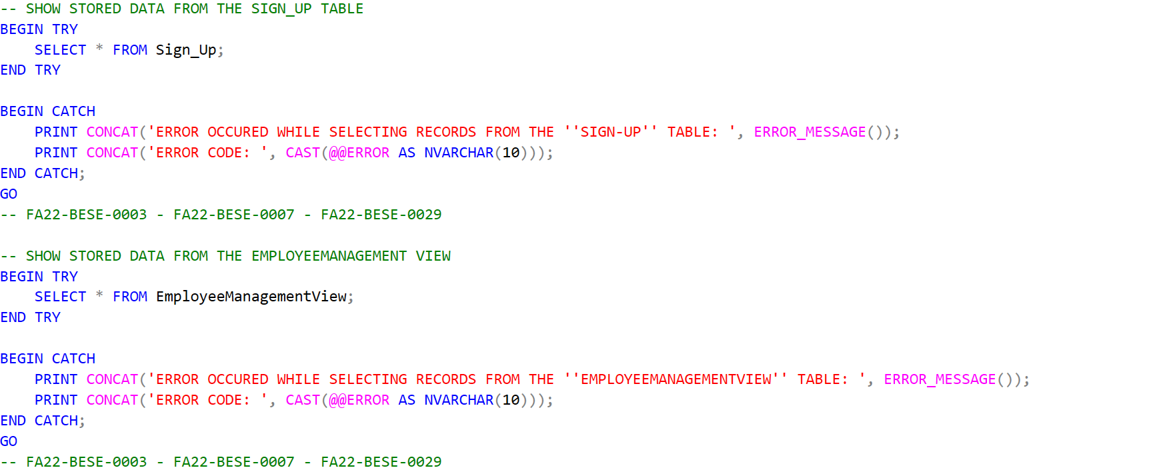

QUERY 19 & 20:
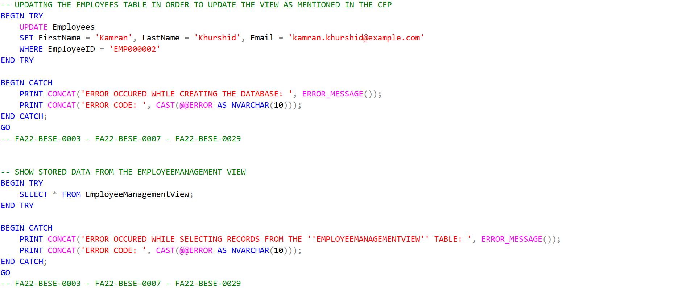

SQL RESULT SCREENSHOTS
RESULT 01:
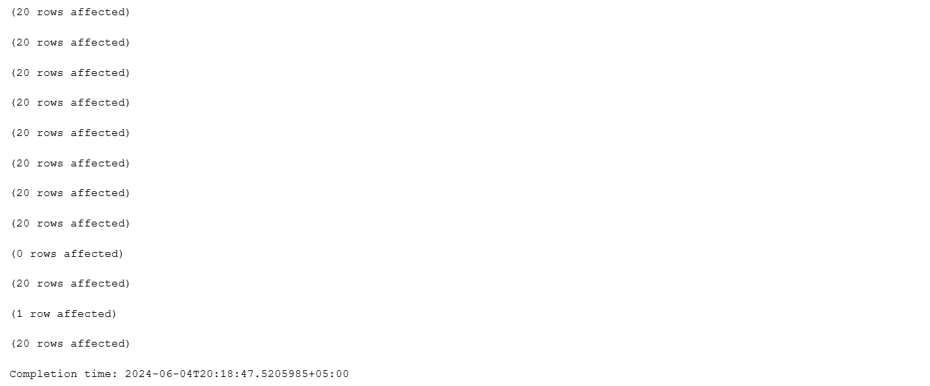

RESULT 02:
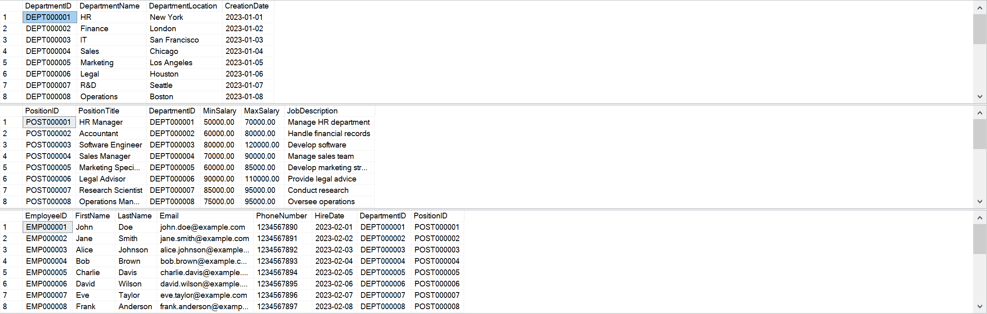

RESULT 03:
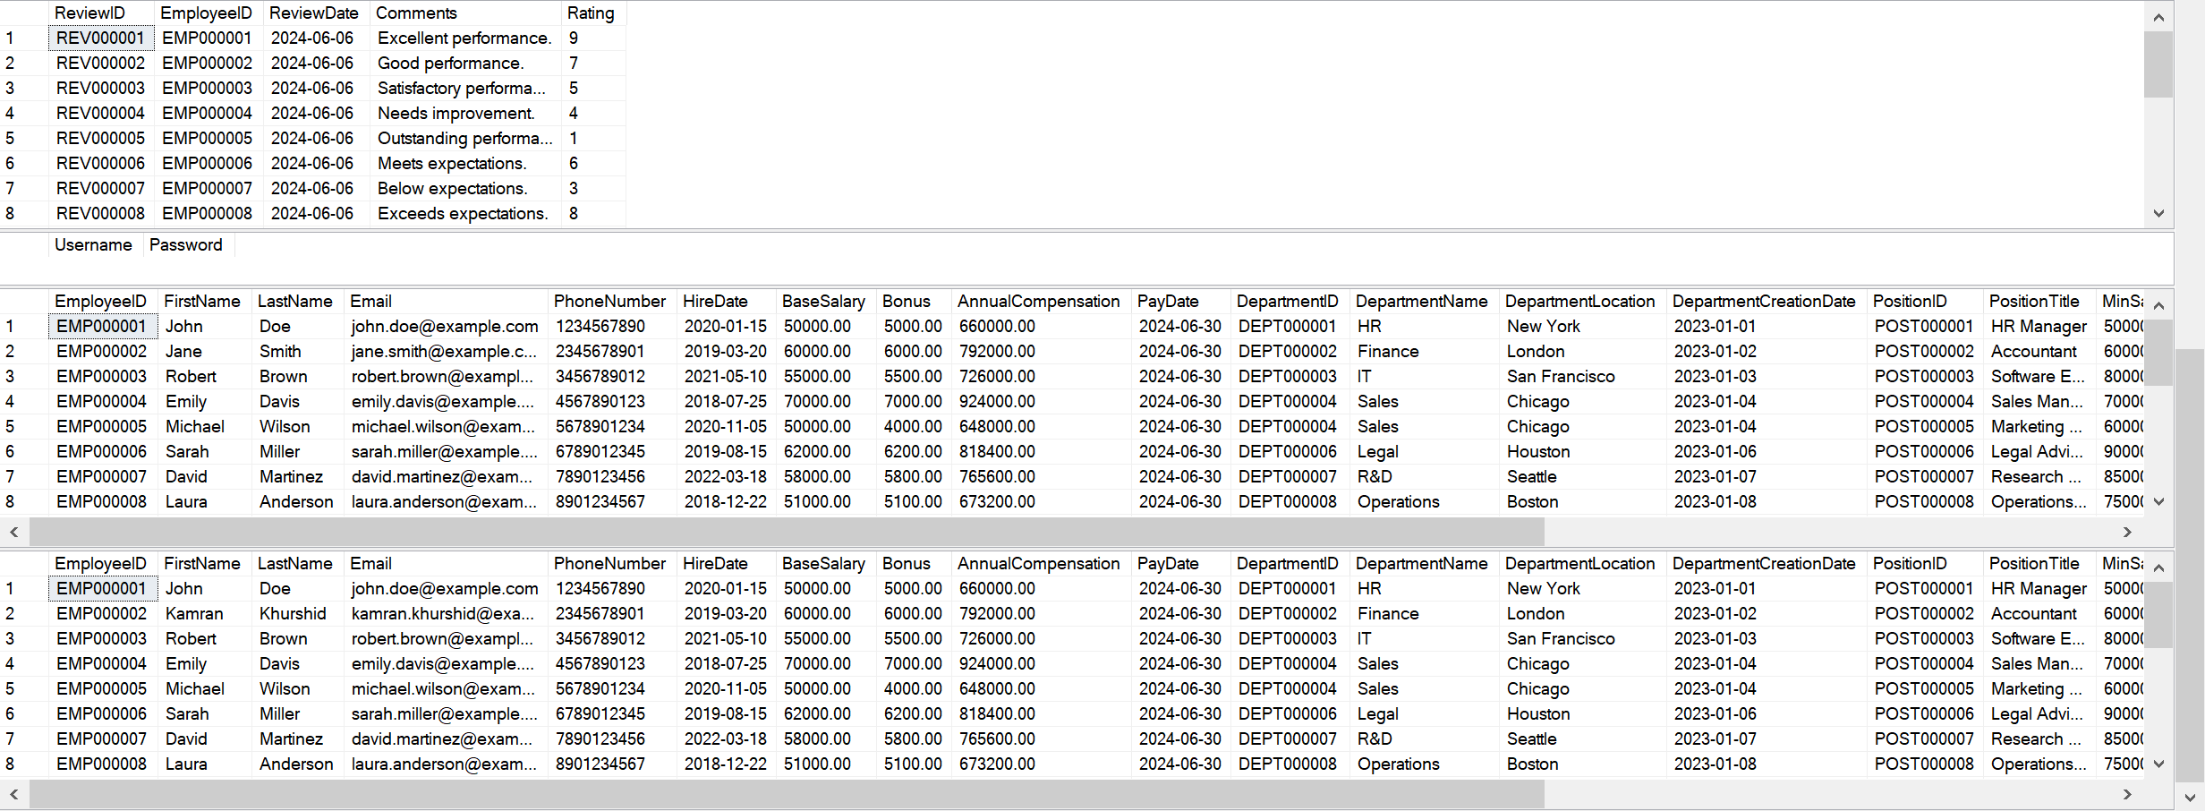

PYTHON IMPLEMENTATION
- Signup: The signup feature allows new users to register by providing a username and password to the system. Passwords are converted to their hexadecimal representations for security concerns and then stored in the ‘Sign_Up’ table along with a unique username for each user, enhancing security.
- Login: The login feature verifies user credentials by comparing the hash of the password entered at runtime with the password hashes that are already stored in the database. Successful verification of user credentials at the login page grants access to the employee management system (EMS), ensuring secure and reliable authentication.
- Add Department: This feature enables the user to add new departments to the EMS. Administrators can create departments by providing the credentials requested by the system.
- Display Departments: This feature retrieves the details of all departments from the database and displays them in the console, providing a list of departments existing within an organization and assisting users to view and manage organizational structure.
- Add Position: Similar to adding departments, this feature allows the addition of new job positions to the ‘positions’ table.
- Display Positions: This feature retrieves the details of all positions from the database and displays them in the console, providing a list of positions available within each department. It helps in understanding the job hierarchy and available roles.
- Add Employee: This feature allows the addition of new employees to the ‘Employees’ table. The system will ask the user to enter employee details, such as employee ID, first name, last name, and email etc.
- Display Employees: This feature retrieves the details of all employees from the database and displays them in the console, providing a list of employees working inside each department and position offering a comprehensive view of the workforce.
- Update Employee: This functionality enables updating existing employee records. Changes to employee details are saved to the ‘Employees’ table, ensuring data accuracy.
- Remove Employee: This feature allows the removal of employee records from the database. The specified employee is removed from the ‘Employees’ table.
- Add Performance Reviews: This feature enables the user to add information regarding employee performance to the ‘Performance Review’ table by asking for details such as comments and performance rating etc.
- Display Performance Reviews: This feature retrieves all records from the ‘Performance Reviews’ table and displays them in the console, providing a view of employees’ performance.
PYTHON COSNOLE SCREENSHOTS
OUTPUT 01:
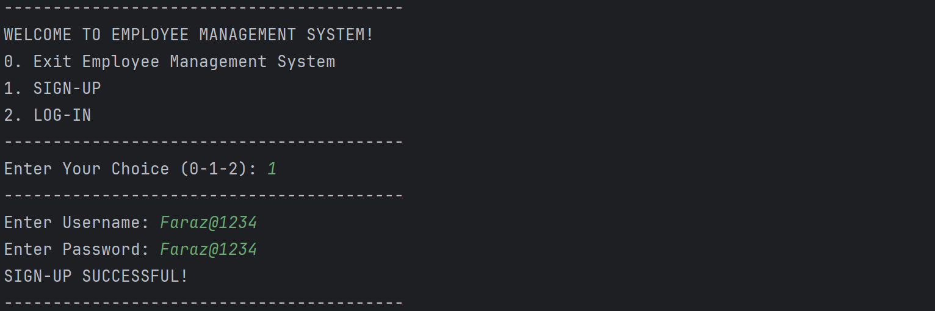

OUTPUT 02:
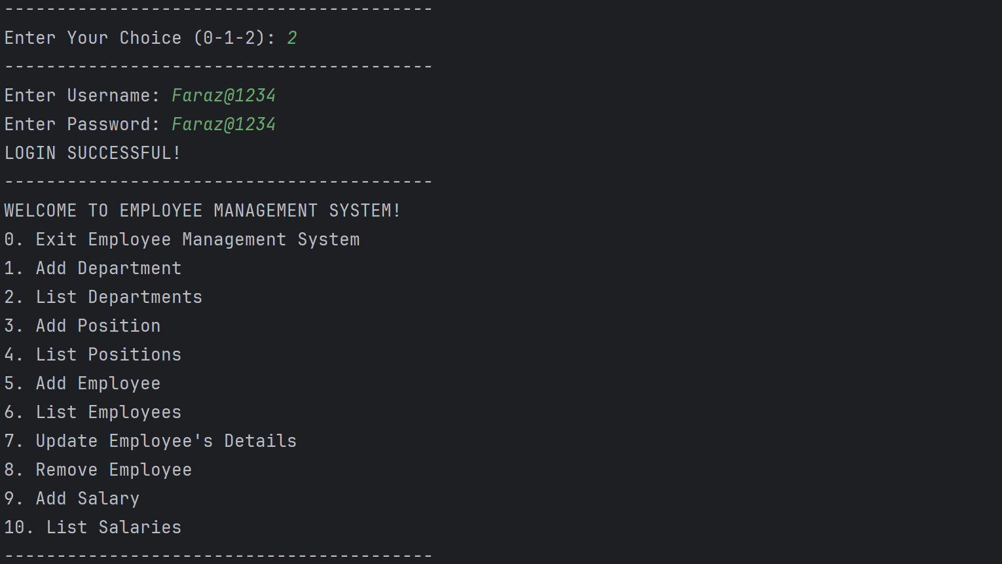

OUTPUT 03:
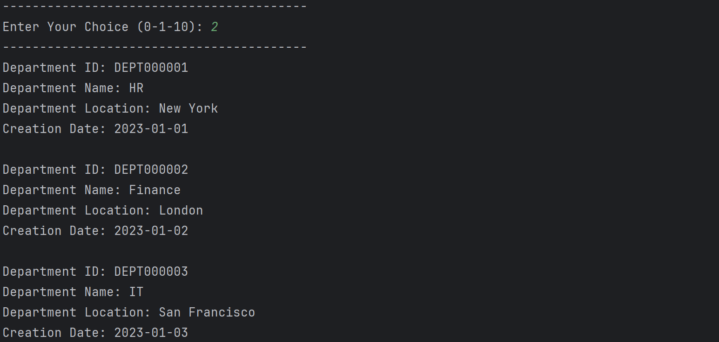

OUTPUT 04:
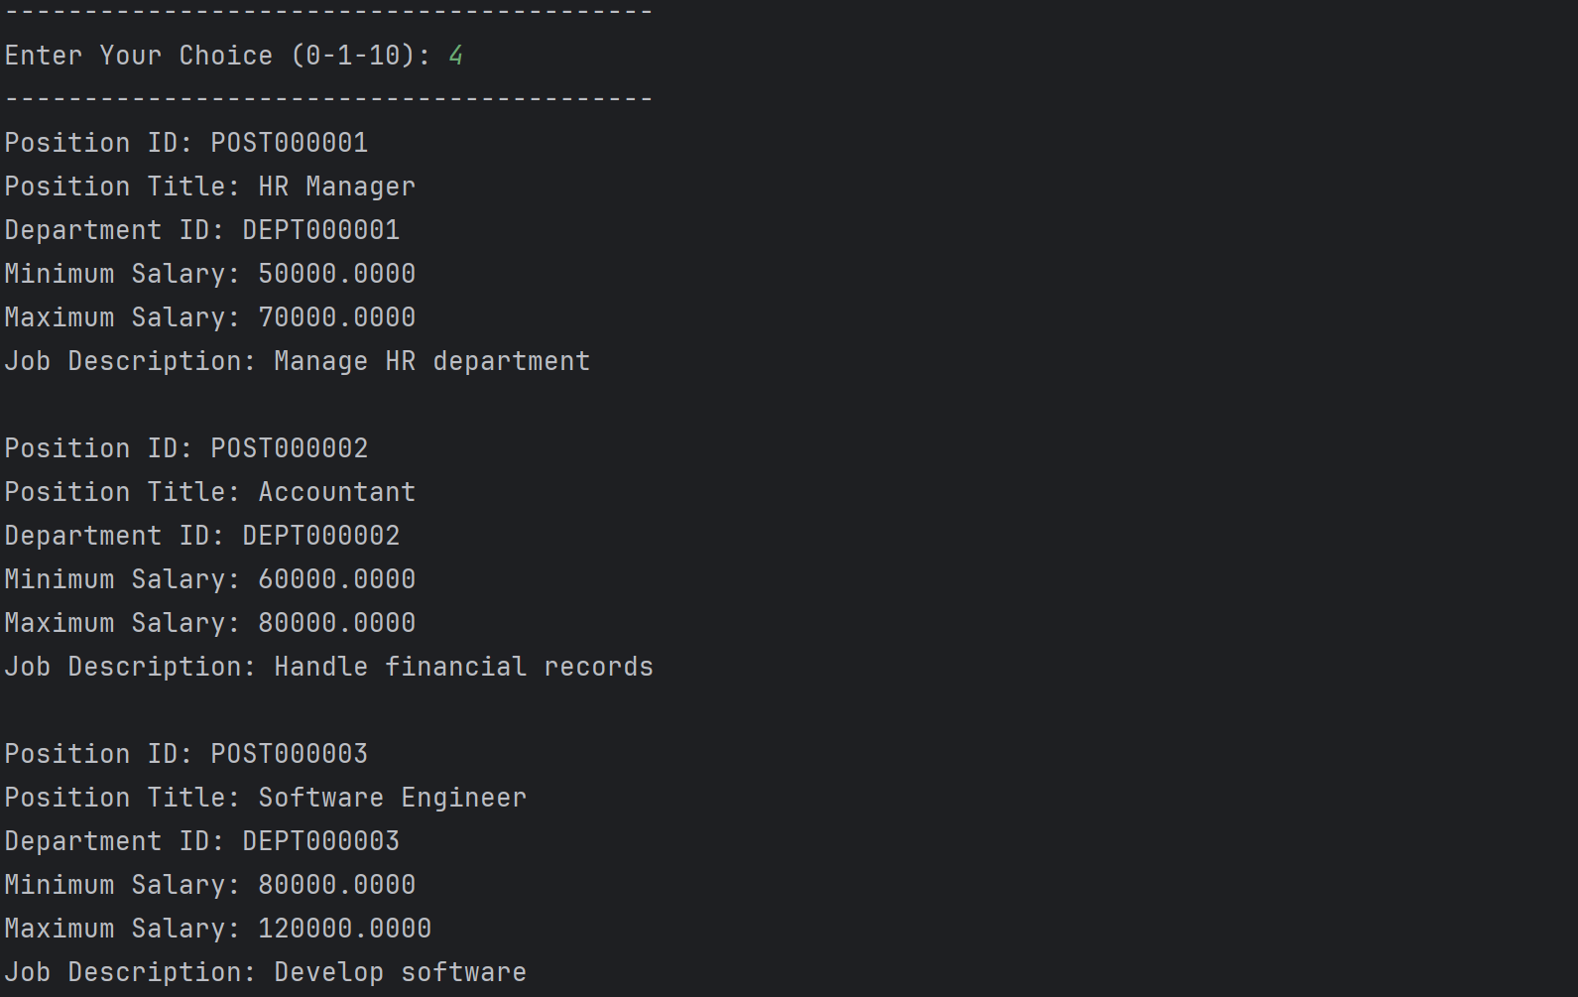

OUTPUT 05:
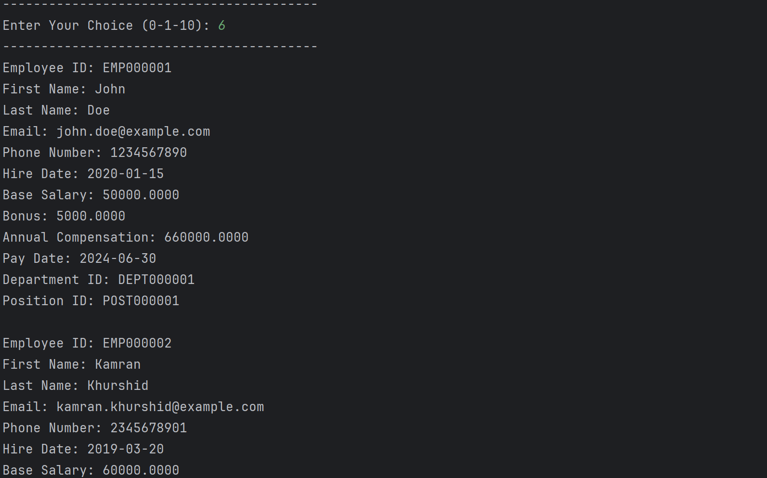

OUTPUT 06:
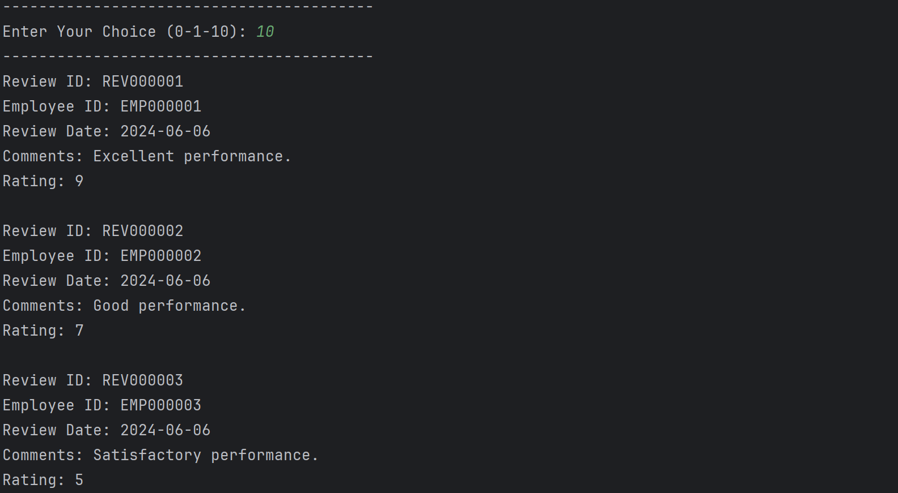
CONCLUSION
- SQL SERVER: THE BEDROCK OF DATA INTEGRITY AND SECURITY
SQL Server serves as the rock-solid foundation of the EMS. Its robust data management capabilities ensure the accuracy and consistency of employee information. Features like data validation, access controls, and disaster recovery mechanisms safeguard sensitive employee data, fostering trust and compliance with regulations.
- PYTHON: THE AGILE ENGINE FOR USER-FRIENDLY FUNCTIONALITY
Python, known for its readability and extensive libraries, acts as the agile engine driving the user-friendly interface of the EMS. This allows for the creation of intuitive dashboards, reports, and functionalities that streamline administrative tasks. Employees can access and update their information effortlessly, while HR personnel can leverage powerful analytics to gain insights into workforce trends.
- A SYMPHONY OF STRENGTHS: A COMPREHENSIVE SOLUTION
The synergy between SQL Server and Python extends beyond individual strengths. Together, they enable the development of a comprehensive EMS solution. This solution can encompass a wide range of features, including:
- Employee Onboarding and Offboarding: Automate workflows for a smooth onboarding experience and efficient offboarding processes.
- Performance Management: Track employee performance through goal setting, progress monitoring, and feedback mechanisms.
- Payroll Integration: Integrate seamlessly with payroll systems for streamlined salary processing.
- Reporting and Analytics: Generate insightful reports on employee demographics, performance, and trends, empowering data-driven decision making.
- A SCALABLE SOLUTION FOR FUTURE GROWTH
The chosen technology stack ensures the EMS is not just powerful but also scalable. SQL Server's ability to handle large datasets makes the system adaptable to growing organizations. Python's vast community and extensive libraries provide a wealth of resources for feature development and customization in the future.
In conclusion, the Employee Management System (EMS) implemented using SQL Server and Python offers a strategic partnership for organizations. It goes beyond efficiency, providing a comprehensive, secure, and user-friendly solution to manage your most valuable asset: your workforce. The system's comprehensive features support various administrative tasks, making it a valuable tool for any organization.

